**Raising Standards in KS4 – The last 8 weeks**

*Calculating Progress 8 – Is it time to ‘park the bus’.*

In January and February I have had the privilege to be in a range of schools supporting progress and achievement at KS4 for both Alps and PiXL.

A common query from Headteachers and KS4 Raising Standards Leaders (RSLs) has been around the issue of calculating their 2017 Progress 8 score based on teacher predicted grades. Many are using a variety of means to try to calculate their Progress 8 score.

In a sense, I do ‘get’ this because of the huge impact the Progress 8 score has, for example in terms of being labelled ‘coasting’ or ‘below floor standard’, but I suspect time and energies could be better spent elsewhere.

The reality is that no-one can know what their actual 2017 Progress 8 score will be with any degree of certainty until they are announced in October. It is important to remember the following:

* P8 will be based on 2017 data.
* 0.00 will be the national average score in 2017 (based on 2017 results).
* P8 in 2017 will use the transitional A*-G point scores whereas the extract from 2016 Attainment 8 calculations below, from *Progress_8_school_performance_measure_Jan_17*, do not.

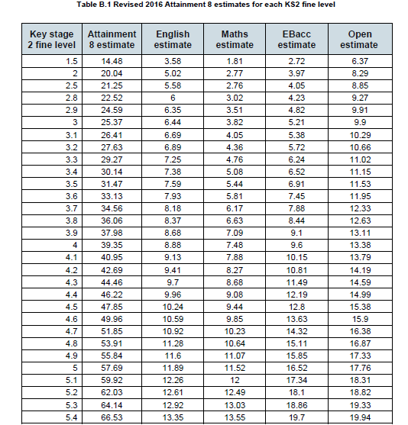

* Let’s look at the Attainment 8 English estimate of 10.24 for a student on 4.5 at KS2. In 2016 students with that KS2 fine-grade score did slightly better on average than gaining C (worth 5) as their best English grade. As only a third of the students who gained C in 2016 will be awarded grade 5 in 2017 these estimates (and those based on the transitional A*-G points that awards Cs 4 points) must surely fall.
* Why waste too much time generating detailed Progress 8 scores when, even if your teachers have their predicted grades ‘spot-on’, the numbers generated are almost certain to be (extremely) wrong?

**Maxing Student Achievement and Progress in the last 8 weeks**

This much I do know and hold to be true:

* 1. The only way to improve your potential Progress 8 score is to improve your results.
  2. Focus your energies on further improving predicted attainment by concentrating on raising subject outcomes.
  3. In turn, that can only be achieved by raising the performance of specific targeted students.
  4. English and Maths can contribute up to 50% of each students’ P8 score and Science can contribute up to 20 or 30% as well, so having the primary focus on those 3 faculties is the right strategy.
  5. Raising grades from C upwards on legacy A*-G qualifications has been incentivised in 2017 and 2018 by the 1.50 point gains available. Do NOT ignore the needs and progress of your more modestly able learners but do ensure that all students with the ability to gain the highest grades do so. Do you know, subject by subject, who your A*/A, A/B and B/C key marginals / boundary leapers are?
  6. If you have used systems to mimic Progress 8 – and please don’t say you haven’t as I will not believe you – although your scores will (probably) be wrong your scale may well be right.
     1. So which bucket has the poorest score and why? What are you going to do to improve it?
     2. Which groups, by disadvantage, SEN, gender, ethnicity or prior attainment are predicted to perform least well? What are you going to do about it?
     3. Which students in which subjects are significantly underachieving? Who is going to do something about it?
     4. Which students who are not underachieving have further capacity to improve and in which subjects?

Time is of the essence. Concentrate now on strategies and priorities that will raise student progress and attainment in the remaining weeks.

Good luck in your endeavours!

And don’t neglect uploading results to Alps on or around GCSE results day to have your VA report in school at the start of September, analysing results at school, subject, teaching set and student level so you are able to see how successful you have been and set the right improvement strategies for 2017-18.

John Philip

Senior Educational Consultant

Alps